Strengthen Our SISTERHOOD
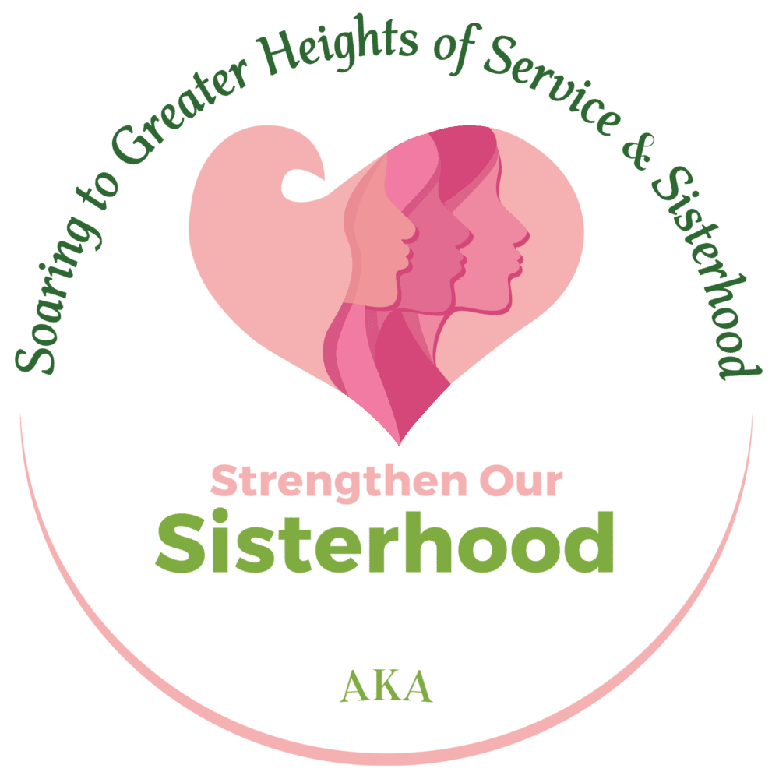
Overview
For more than a century, our sisterhood has served as the foundation for Alpha Kappa Alpha Sorority to be an indomitable force for good—in our communities, states, nation, and the world.
We will intentionally take time to fellowship and form lifelong relationships based on affinity, love, trust, respect, and shared goals and interests, while concurrently building on our foundation to serve others.

Areas of focus
Sister Squads
Soror Squads are focused on building greater bonds of sisterhood around common endeavors or activities through intimate small groups.

AKA Pals
AKA Pals will allow members to create cross-regional relationships to allow for greater fellowship.

Random Acts of Sisterliness
Random Acts of Sisterliness offer an opportunity for members to share random acts of care and compassion.
“We Are One” AKA Service Day
During our annual MLK Day of Service, all members will join together to volunteer and serve the community side-by-side.

Leadership Development
Undergraduate and graduate members, across all life stages, will engage in a modern, interactive, and high-impact leadership development program.

Empower Our FAMILIES
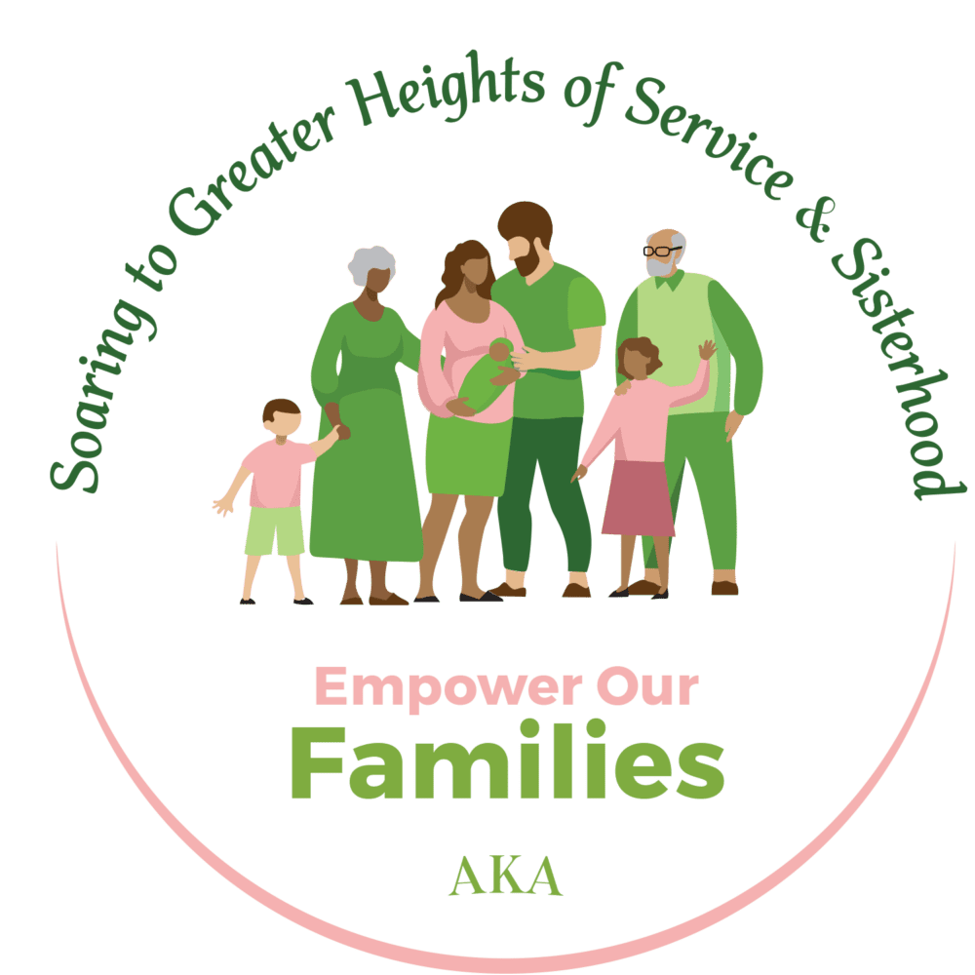
Overview
Alpha Kappa Alpha Sorority has a strong history of supporting and servicing families, for we understand a healthy family is the foundation of a healthy community.

We will take a multi-generational approach to fortify families within our communities by addressing child hunger and promoting positive youth development and leadership, mental well-being, and senior life.

Areas of focus

Childhood Hunger Initiative Power Pack (CHIPP™)
CHIPP provides weekend and holiday meals for children within local communities and is targeted to be Alpha Kappa Alpha’s most ambitious childhood hunger program to date.

Youth Leadership Institute (YLI)
YLI is a youth-led and highly interactive leadership development program designed to empower and engage youth, ages 11-13.

Mental Health Awareness
During Mental Health Awareness month, we will use our collective efforts to fight stigma and raise awareness related to depression, anxiety, and trauma.
Our Seniors
Our Seniors focus on ensuring these members can actively participate in all AKA activities. We also will focus on providing educational programs and workshops to support senior members as they navigate senior life priorities.

Build Our ECONOMIC WEALTH
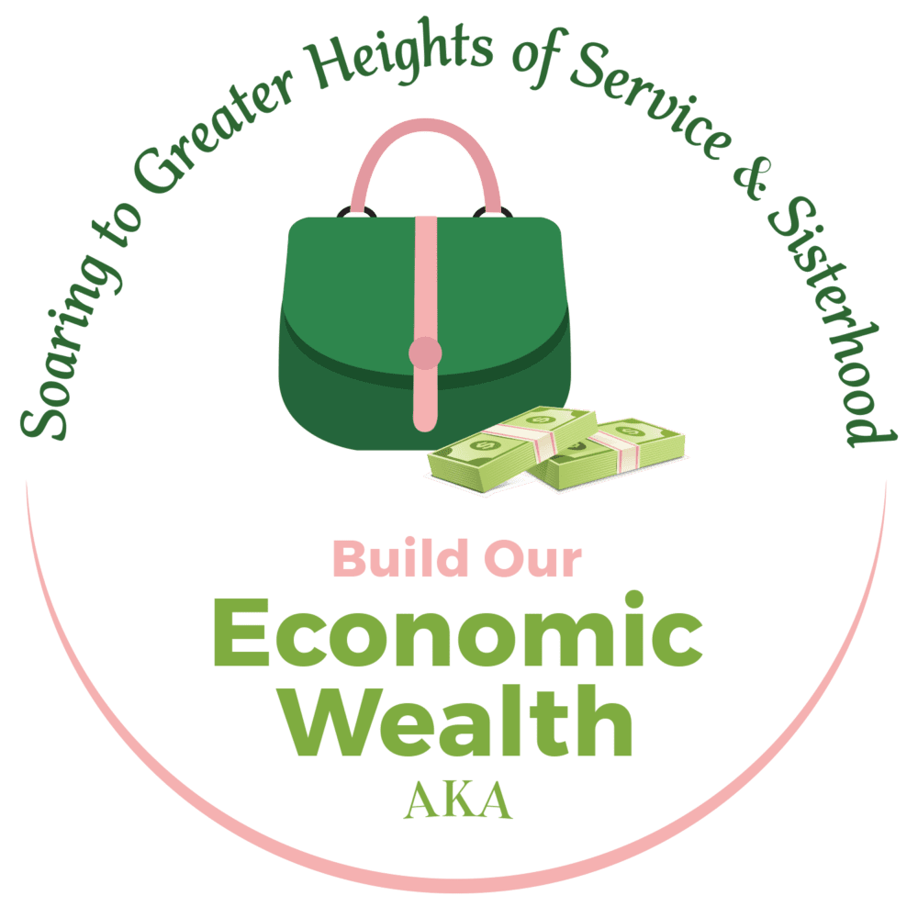
Overview
Alpha Kappa Alpha Sorority is launching our most progressive and revolutionary economic initiatives this century. This administration has created institutional-level solutions to combat institutional-level challenges.
We will further encourage and equip our members to place key strategies into action to build personal, organizational, and community economic wealth.
Areas of focus

For Members Only TM Credit Union
For Members Only Federal Credit Union will be the FIRST, Black-owned, woman-led, sorority-based, digital banking financial institution in the history of the United States.

Financial Wellness & Planned Giving
Financial wellness and planned giving efforts will assist members with legacy planning supported by expert members and wealth management partners.

Sister Circles
Sister Circles are accountability groups designed to help set and achieve personal savings, investing, and giving goals.

Supporting Women Entrepreneurs
Supporting Women Entrepreneurs will focus efforts to promote, celebrate, enhance, reach, raise visibility and offer access for greater revenue-generating opportunities.

Black Dollar Days
Black Dollar Days will be held during the month of June with a focus on leveraging our collective buying power to funnel revenue to Black-owned businesses and brands.

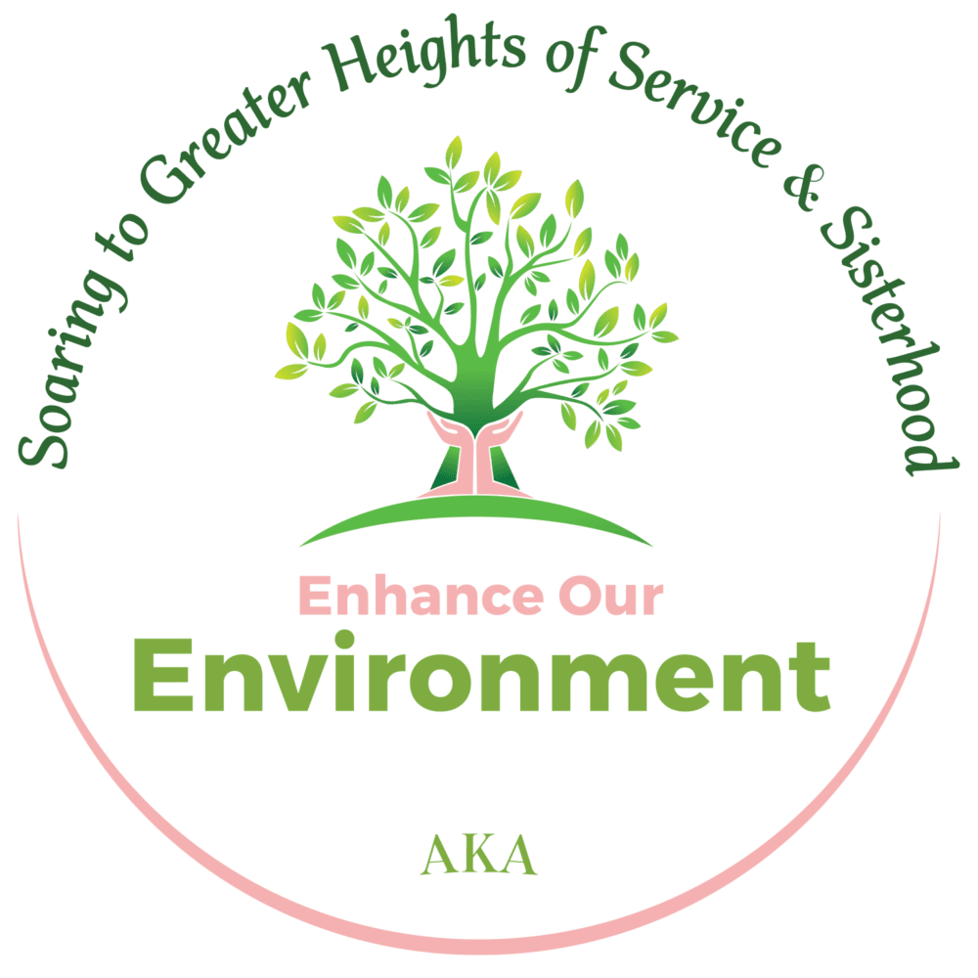
Enhance Our ENVIRONMENT
Overview
Alpha Kappa Alpha Sorority has the power to galvanize our organization of more than 120,000 active members, create a ripple effect, and make a significant impact on our environment.

We will employ select strategies to optimize our collective ability and to improve and protect the environment at scale. We will prioritize activities that promote the adoption of more sustainable and responsible practices.

Areas of focus

Tree Planting
Chapters will track and measure the collective environmental impact of our largest tree planting effort to date.

Community and Home Gardens
Chapters and individuals will create community and home gardens to reduce negative environmental impact and promote sustainable agriculture.
Waste Reduction
Waste reduction efforts will engage individuals and communities in eco-friendly practices to reduce household waste.

Shredding and Electronics Recycling Day
Shredding and Electronics Recycling Day is an annual event to safely dispose of unused electronic devices and securely shred old paper documents resulting in reducing the burden on landfills and natural resources.

Advocate For SOCIAL JUSTICE
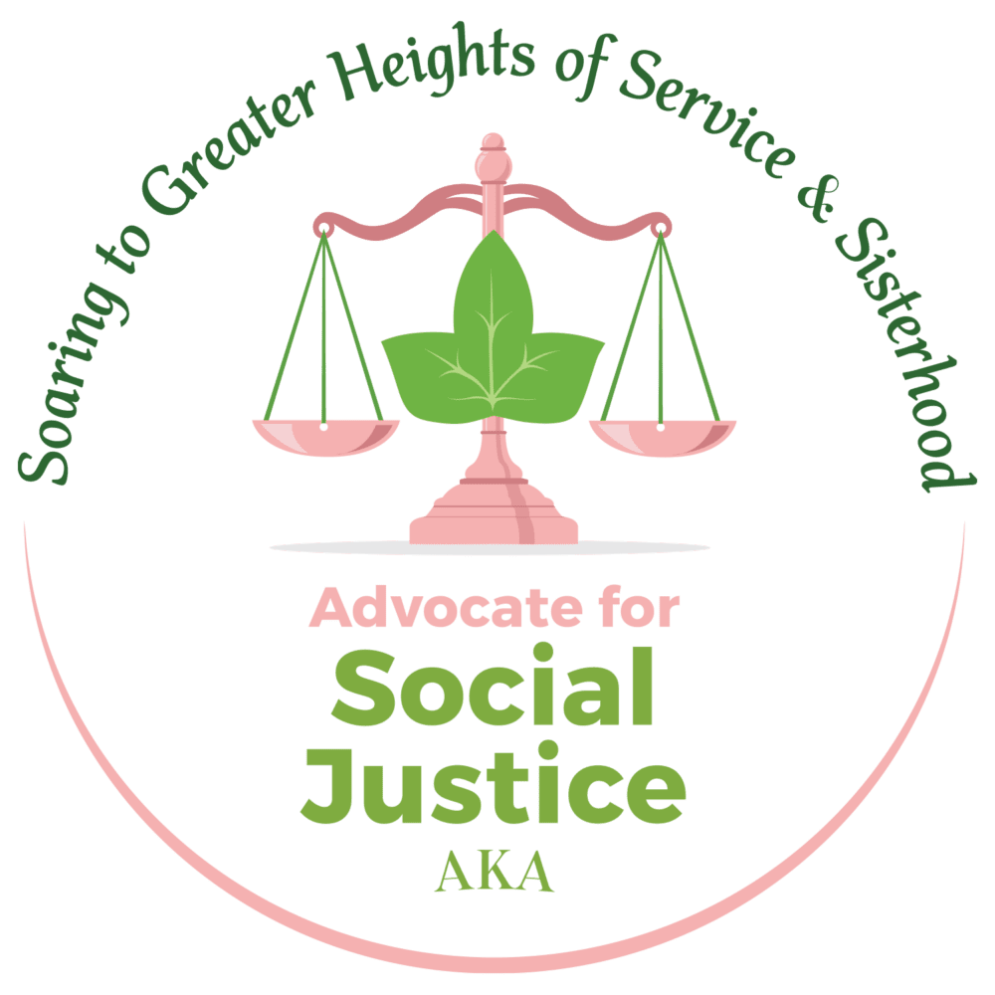
Overview
Alpha Kappa Alpha Sorority always has been at the forefront of social justice to promote fairness and equity. We stand in the gap to empower our communities and act in the best interests of all people through social advocacy and justice.

We will equip communities with the tools, knowledge, and support to activate their voices and mobilize self-help to empower communities to help themselves.
Areas of focus
Voter Education, Registration, and Mobilization
Voter education, registration and mobilization efforts will empower communities to utilize their most powerful tools of community change and advocacy during local, state, and national elections.

Public Policy Forums
Public Policy Forums will create convenings of non-partisan, open dialogue on policy challenges and the direction of our country.
Candidate Forums
Candidate Forums are non-partisan public events featuring candidates running for office who wish to express their positions on issues.

Public Servant’s Guides
Public Servant’s Guides will provide concise overviews highlighting women of color currently serving in political leadership positions along with information on how to create a pathway for women in politics.

Uplift Our LOCAL COMMUNITY
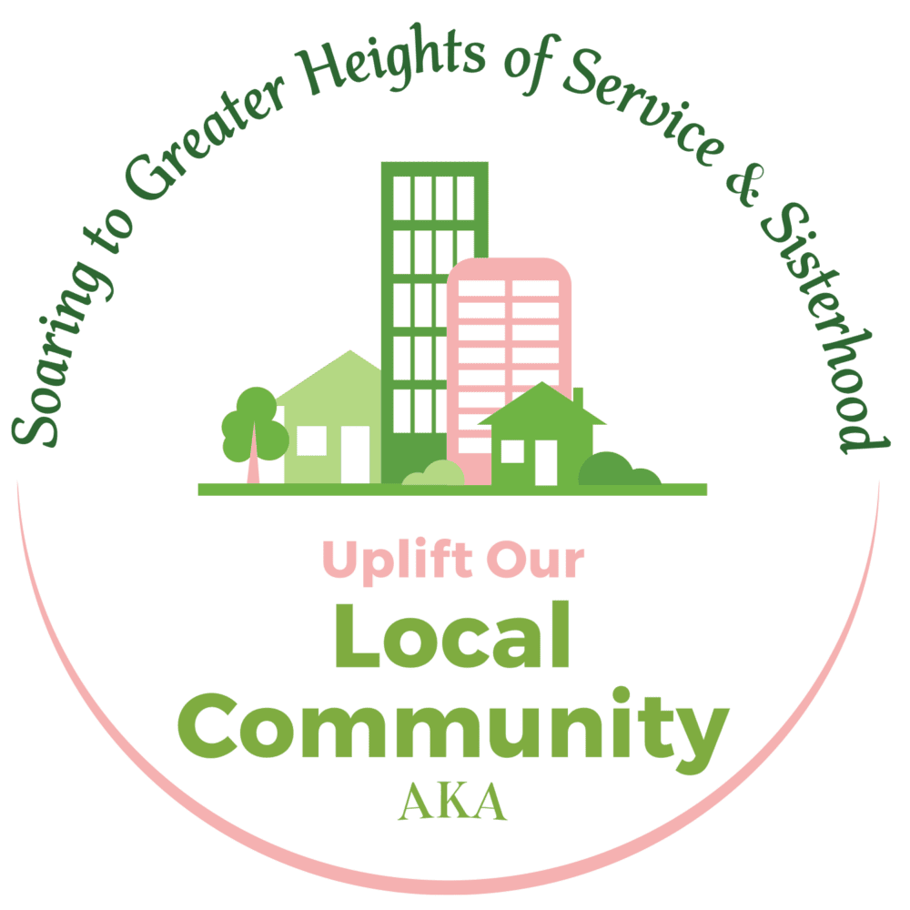
Overview
Alpha Kappa Alpha Sorority reigns supreme in its mission of “Service to All Mankind.” Given the engagement of more than 1,046 chapters across an international landscape, we have an ongoing history and reputation for making a global impact through local change.

We will celebrate excellence, promote a focus on service, and stimulate effective culture and showcase best practices—” Local Change, Big Impact, and Global Showcase.”

Areas of focus

Celebrating Local Community Impact
This recognition program celebrates chapters that have made an exceptional impact in their local community.

Chapter Collaboration Recognition Program
This recognition program acknowledges chapters that have collaborated to combine resources and efforts by maximizing the impact in their community.

